

ACRM Technical Design

Project: | TMS
SSR #:
Title: | Automated Customer Risk Management (ACRM) To Data Hub Interface
Date: | June 04, 2013
Version: | 1.2
Status: | Draft

Document Ownership:
Name | Organization | E-mail | Telephone #
Henry Lan | IBS-RM | Henry.Lan@scrotiabank.com

Document Version History:
Version | Name | Organization | Signature | Date
1.0 | Henry Lan | IBS-RM |  | Apr 02, 2013
1.1 | Henry Lan | IBS-RM |  | Jun 04, 2013
1.2 | Henry Lan | IBS0-RM |  | Jun 26, 2013

Document Review:
Name | Organization | Signature | Date

Document Approval:
Name | Organization | Signature | Date
Table of contents
1 Overview 4
2 Scope 5
3 Background 6
4 Assumptions 7
5 Prerequisites 8
6 Constraints 9
7 Input & Output 10
8 Technical Design 11
8.1 Requirements 11
8.2 Functional Specifications 12
8.2.1 EOD Batch 12
8.2.2 Generate the current full load file On-demand 13
8.2.3 Generate the daily delta file for a previous business date On-demand 14
8.2.4 Historical extraction recovery 15
8.3 Diagram 16
8.3.1 Generating Full Load file (EOD or On-demand) 16
8.3.2 Generating daily delta file (EOD) 18
8.3.3 Regenerate a daily file for a previous business date 19
8.4 Implementation 20
8.4.1 ACRM UI 20
8.4.2 ACRM DTO 23
8.4.3 Workflow of Business component 24
8.4.4 ACRM Data Mapping and Table definition 26
9 Security 29
10 Archiving 29
11 SLA (Service Level Agreement) 29
12 Problem Recovery 29
13 Deliverables 29
14 Appendix 29

Overview

The ACRM application will query Bankfusion and Opics database to extract BFUB customer information, and output the extraction to text files. The generated CIFs files will be used to match against sanction list in World Check to identify “high-risk individuals or entities”.

ACRM will extract CIFs files automatically or on-demand.
- The EOD batch job will generate a daily file containing new and changed CIF information (i.e. daily delta file) automatically
- ACRM extract is developed to provide the entire customer base (i.e. a full load file) on demand
- The same ACRM extract has the ability to regenerate a daily delta file for a previous business date if the previous date is not old than a month.

The ACRM extract file will be transmitted via Connect Direct to the Data Hub. (Will check with Compliance IT, and update the document)

Scope
The scope is for SIJL only.

Background
The bank has a legal responsibility to block transaction, freeze funds, and/or report to regulators customers who are categorized as terrorists or criminals. The ARCM application will provide customer information extraction to support an automated name scanning functionality checking customers’ names against sanction lists.

Assumptions

- Since we do not have direct access the World Check sanction lists, the ARCM extract information of all customers dealing with SIJL. The extract file is used to match our customer names against World Check.

Prerequisites

- Accessing Bankfusion database is required
- Connect Direct test environment is required

Constraints

Input & Output

Input:
Bankfusion and Opics database

Output:

Daily File: Develop a daily file containing new CIF setup and CIF maintenance information, excluding all prospect clients and all customers no longer actively dealing with SIJL, from SIJL TMS to interface with the ACRM database for hot list screening purpose.

Full-load File: Develop the functionality to provide the entire customer base (i.e. a full load file) to interface with the ACRM database both at the initial implementation and subsequently on demand.

Technical Design

Requirements

Extracts customer information from Bankfusion to text files automatically or on-demand. Refer to “I7 Anti Money Laundering Monitoring ACRM”

Functional Specifications

The CIFs files will be generated automatically (EOD Batch) or on-demand (Opics form). Both EOD batch and on-demand form must not create negative impacts to regular business activities.

EOD Batch

At the end of each business day, a batch process generates a daily file containing new and changed CIF information. User input is not required in this case.
The batch process captures all CIFs changes happened during work hours, and extracts all required fields for all changed client records from database to a text file.

These are the functional steps that will be implemented for the EOD Batch
- Queries all customer information from Bankfusion and Opics databases and outputs required fields into the ACRM table during the first-time execution of the EOD batch. The first time full load data is the baseline of all CIFs.
- At the end of each business day, the EOD batch captures all changed CIFs and new CIFs, the required fields of all changed customers and all new customers are saved into ACRM table as snapshot records. The record status is “C” for changed CIFs, and “N” for new CIFs
- Extracts captured records from ACRM table to the daily delta file, and transmits the file to the Data Hub

Generate the current full load file On-demand

User can generate the full load file for the current date.

User should check the Full Load checkbox, leave the Extract date blank, and click the Start command button.
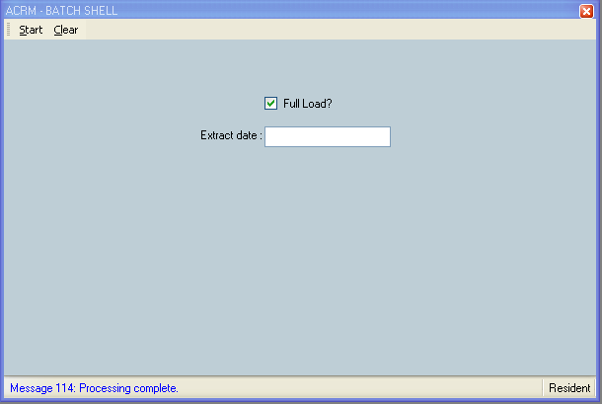

These are the functional steps that will be implemented for generating CIFs files by using Opics ACRM form
- Business user runs the ACRM online extract, and inputs appropriate parameters
- After user issuing the Start command, the request is sent to Opics business component
- Opics business component queries BFUB, and outputs the query results into text file
- The extracted file is transmitted to the Data Hub

Generate the daily delta file for a previous business date On-demand

User can generate daily delta file for a previous business date which is not older than a month

User should uncheck the Full Load checkbox, input a valid previous business date, and click the Start command button.
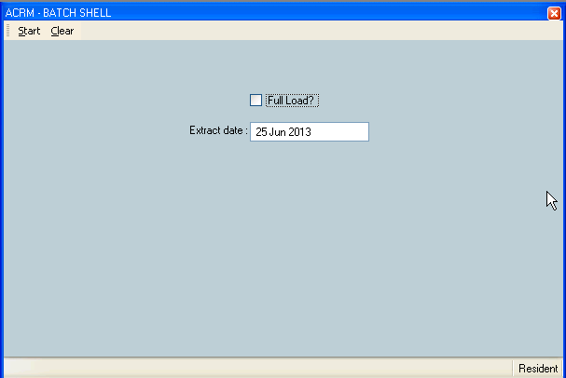

These are the functional steps that will be implemented for generating CIFs files by using Opics ACRM form
- Business user runs the ACRM online extract, and inputs appropriate parameters
- After user issuing the Start command, the request is sent to Opics business component
- Opics business component queries ACRM table to get historical data, and outputs the query results into text file
- The extracted file is transmitted to the Data Hub

Historical extraction recovery

User may want to recover a full load extraction for a previous date; or to recovery a daily delta file for a previous business date which is older than a month. In this case the historical extraction can be obtained from the TSM archive. This may require a ticket and involvement of the dev group to retrieve the file from the external TSM archive.

Diagram

Extracted files are generated in four scenarios

- Generating the full-load file (EOD and On-demand)
- Generating the daily delta file (EOD)
- Generating daily file for a previous business date (On-demand)

Generating Full Load file (EOD or On-demand)
Bankfusion DB

Opics DB
ARCM table

Connect Direct

Business Component
Full-load extraction request is received
Query CIFs from BFUB and Opics, and saves CIFs into ACRM table. Each saved records has a timestamp to indicate extracting time
Creates the extraction file by using ACRM table
transmits extraction file via Connect Direct
BSYS (EOD)

Opics DB

On-demand

Generating daily delta file (EOD)

BSYS (EOD)

BankFusion DB

Opics DB
ARCM table

Connect Direct

Business Component
Daily file extraction request is received from EOD batch
Queries CIFs from BFUB and Opics to check new or updated CIFs. Save the new and updated CIFs into ACRM table
Extracts new or updated CIFs to the daily file
transmits daily file by using Connect Direct
OPICS DB

Regenerate a daily file for a previous business date

Business Component
File extraction regeneration request, the passed in parameters are previous date
Queries ACRM table with previous date, and gets CIFs to generate required extraction file
transmits extraction file by using Connect Direct
On Demand
(Previous business)
Opics DB ARCM table

Connect Direct

Implementation

ACRM UI

- EOD batch

- BBFT – Setup batch parameters
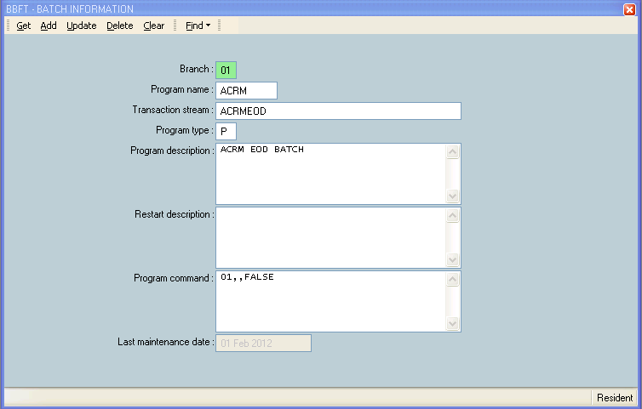
Branch No: 02, not used in ACRM
Extract Date: The value is null always. Business component translates null to the latest business date
Fulll-oad: The value is False always. Business component determines the value. For the first time EOD request Full-load extract is generated; otherwise daily delta file is generated

- BSYS (EOD batch window)
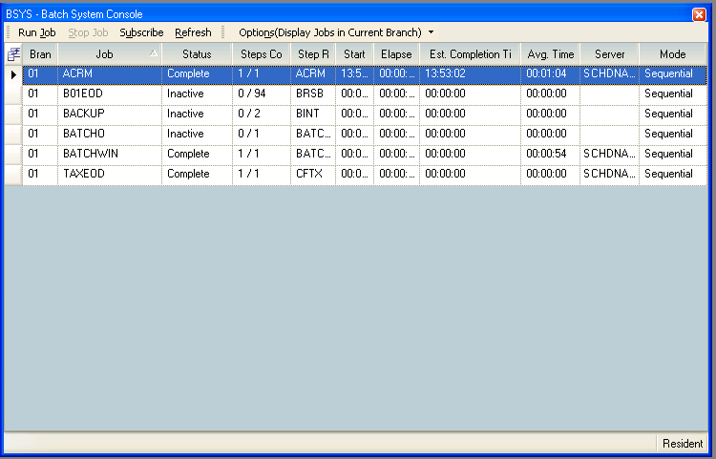

- On Demand form
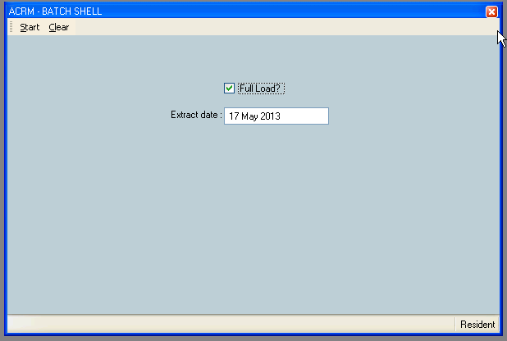

Parameter:
Extract Date (Date Picker): Default value is null, and user can input a previous business date. Business component translates null to the latest business date
Full-load (check box): Default value is unchecked, and user can check it. Checked value means full-load extract request, otherwise daily delta extraction is generated

ACRM DTO

Data transfer object is an interface object used to pass the data from Client to Server and vice versa. DTOs will be created with UI and BC.

Two properties are defined in DTO
- ExtractDate
- IsFullLoad

Workflow of Business component

Business component process UI requests and performs file extraction and transmission tasks
Extract request received
Is EOD?
First time file extraction?
Query Bankfusion and OPICS to get CIF for all customers who have at least one product
Yes
Save all CIF records into ACRM table
Yes
Save delta records into ACRM table
No
No
(EOD and the first extraction)
Get all latest CIFs from ACRM table to generate full-load file
Parameters and Status expression
(EOD and not the first extraction)
Get latest delta CIFs from ACRM table to generate daily file
(On Demand, extract date and full-load parameters)
Get CIFs from ACRM table by using previous date parameter to generate full-load file
(On Demand, extract date and daily parameters)
Get CIFs from ACRM table by using previous date parameter to generate daily delta file
Transmit extract via Connect Direct

ACRM Data Mapping and Table definition

Filed # | Field | Notes | Data Source
1 | RecordID | D=detail  T=Trailer
2 | Local Country Code | JM
3 | Transit Number | Domicile branch/Transit number  of the customer record | MSDEV.WASADMIN.CUSTOMER.BRANCHSORTCODE. 49775 for SIJL
4 | Customer Type | Business or Individual | MSDEV.WASADMIN.CUSTOMER.CUSTOMERTYPE
5 | CIF Key | Customer Number or Identifier on source system | MSDEV.WASADMIN.CUSTOMER.CUSTOMERCODE
6 | Last Name | For individual customer only | MSDEV.WSADMIN.PERSONDETAILS.SURNAME
7 | Second Last Name | For individual customer only | Surname at Birth
8 | First/Middle Name | For individual customer only | MSDEV.WSADMIN.PERSONDETAILS.FORENAME  MSDEV.WSADMIN.PERSONDETAILS.MiddleName (50)
9 | Alias | For individual customer only | Leave Blank
10 | Customer Since | YYYYMM format | MSDEV.WASADMIN.CUSTOMER.UBCREATEDTTM
11 | Sex | Text description, for individual customer only | MSDEV.WASADMIN.PERSONDETAILS.Sex
12 | Customer Title | For individual customer only | MSDEV.WASADMIN.PERSONDETAILS.Title
13 | CustomerLanguage |  | MSDEV.WASADMIN.CUSTOMER.PreferredLanguage
14 | Birthdate | For individual customer only; YYYY-MM-DD | MSDEV.WASADMIN.PERSONDETAILS.DateofBirth
15 | Tax ID |  | MSDEV.WASADMIN.CUSTOMER.TaxNumber
16 | Address line One |  | MSDEV.WASADMIN.ADDRESS.AddressLine1  Customer--CustomerDocDTL(CustomerCode,DocID)--Address(DocID)
17 | Address line two |  | MSDEV.WASADMIN.ADDRESS.AddressLine2
18 | City |  | MSDEV.WASADMIN.ADDRESS.AddressLine5
19 | Province/State Description |  | MSDEV.WASADMIN.ADDRESS.AddressLine6
20 | Country of Address |  | MSDEV.WASADMIN.ADDRESS.AddressLine7
21 | Country of Citizenship |  | MSDEV.WASADMIN.PERSONDETAILS.UBCitizenship
22 | Country of Domicile |  | MSDEV.WASADMIN.PERSONDETAILS.CountryOfDomicile
23 | Client Type Description | Leave Blank
24 | Occupation Code | Leave Blank
25 | Occupation Description | For individual customer only | WASADMIN.UBTB_CUSTEMPLOYMENTDETAILS.UBPOSITION
26 | Employer | For individual customer only | WASADMIN.UBTB_CUSTEMPLOYMENTDETAILS.CurrentEmployer
27 | Work Phone | For individual customer only | MSDEV.WASADMIN.[UBTB_CUSTOMERCONTACT].[UBCONTACTMEDIUMDETAILS]
28 | Home Phone | For individual customer only | MSDEV.WASADMIN.[UBTB_CUSTOMERCONTACT].[UBCONTACTMEDIUMDETAILS]
29 | E-Mail ID |  | MSDEV.WASADMIN.[UBTB_CUSTOMERCONTACT].[UBCONTACTMEDIUMDETAILS]
30 | Name of spouse | For individual customer only | Leave blank
31 | Spousal Tax ID | For individual customer only | Leave blank
32 | Name Line One | For business customer only | MSDEV.WASADMIN.ORGDETAILS.ORGName
33 | Name line two | For business customer only  Additional line to hold business customer name if Field #32 is not long enough
34 | SICCode Description | For business customer only  Standard Industry Code | CUST.SIC
35 | Country of Birth | For individual customer only | MSDEV.WASADMIN.PERSONDETAILS.UBCountryOfBirth
36 | City of Birth | For individual customer only | MSDEV.WASADMIN.PERSONDETAILS.UBPlaceOfBirth
37 | Father Name | For individual customer only | MSDEV.WASADMIN.PERSONDETAILS.Fathername
38 | MotherName | For individual customer only | MSDEV.WASADMIN.PERSONDETAILS.UBMotherMaidenName
39 | Child Name1 | For individual customer only | Leave Blank
40 | Child Name2 | For individual customer only | Leave Blank
41 | Trading Name | For business customer only | MSDEV.WASADMIN.CUSTOMERDOCDTL.UBDOCUNIQUEREF (DOCTYPER=Legal)
42 | Date of Business Established | For business customer only. YYYY-MM-DD | MSDEV.WASADMIN.ORGDETAILS.ESTABLISHEDDate
43 | Registration Number | For business customer only | MSDEV.WASADMIN.CUSTOMERDOCDTL.UNTRADINGREGNUM (DOCTYPER=Legal)
44 | Location of Registered Office | For business customer only | MSDEV.WASADMIN.CUSTOMERDOCDTL.UBPLACEISSUEREG (DOCTYPER=Legal)
45 | Business Type Description | For business customer only | SCOTIA.SCOTIA_CORPORATEINFO.SCDESCRIPTIONBUSINESS
46 | Business Nature | For business customer only | WASADMIN.PORTFOLIO.PORTFOLIOTYPE  (1087)
47 | Business Structure | For business customer only | WASADMIN.ORGDETAILS.UBISSUBSIDIARYORPARENT (1086)
48 | Key Contact person name | For business customer only | WASADMIN.UBTB_CUSTOMERCONTACT.UBCONTACTMEDIUMDETAILS
49 | Key Contact person Phone Number | For business customer only | WASADMIN.UBTB_CUSTOMERCONTACT.UBCONTACTMEDIUMDETAILS  (UBCONTACTMEDIUMTYPE ='001' Phone, and UBISPREFERREDCONTACT='Y')
50 | Principle owner/director name | For business customer only | WASADMIN.UBTB_CUSTOMERCONNECTIONDETAILS  (UBREFCUSTOMERCODE, UBCUSTCONNECTIONIDPK, UBRelationshipTypeID)
51 | Signing authority of each individual of company | For business customer only | WASADMIN.UBTB_CUSTOMERCONNECTIONDETAILS  (UBREFCUSTOMERCODE, UBCUSTCONNECTIONIDPK, UBRelationshipTypeID)
52 | Number of full time employees | For business customer only | MSDEV.WASADMIN.ORGDETAILS.NoOfEmployees
53 | Number of part time Employees | For business customer only | Leave Blank
54 | Annual sales expected source | For business customer only | WASADMIN.ORGDETAILS.UBPRIMARYBUSINESSACTIVITY
55 | Annual sales expected amount | For business customer only | WASADMIN.ORGDETAILS.ANNUALTURNOVER
56 | Supplier 1 name | For business customer only | Leave Blank
57 | Supplier 2 name | For business customer only | Leave Blank
58 | Apt/Unit/Floor | Additonal address information to indicate  apartment, unit or floor number | Leave Blank
59 | Old/new CIF cross reference kry | Field #5 | CIFKey
60 | Timestamp of Extract | YYYY-MM-DD HH.MM.SS.UUUUUU
61 | Record Status | For daily file, N=New, C=Change  For full-load file, always C
62 | Job Name | Trailer record only
63 | Extract Date | YYYY-MM-DD, source system business date;  Both detail & trailer records
64 | Count | #Customer records in the file. Trailer record only
65 | Database ID | Always 1, if there is only one database in the country  Both detail and trailer records

Security

The following security should be configured for various components:

Name | Type | Description
UI | User Input Screen | OpicsPlus Execution Permission grant to users/groups
Batch step | EOD batch | OpicsPlus Execution Permission grant to users/groups

Archiving

SLA (Service Level Agreement)

Problem Recovery

Deliverables

Appendix

